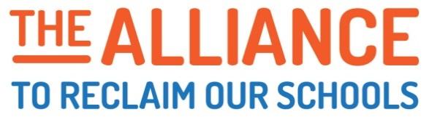
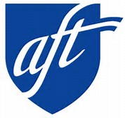
The

JOIN US! Help Build the Movement for Educational Justice on October 6th

The Alliance to Reclaim Our Schools (AROS) is an alliance of parent, youth, community and labor organizations that together, represent over 7 million people nationwide. We are fighting to reclaim the promise of public education as our nation's gateway to a strong democracy and racial and economic justice. Last year AROS launched a national campaign for the Public Schools ALL Our Students Deserve that links local struggles across cities and states.

Great Public Schools
AROS is fighting for: Every Child Every Zip Code
- World class community schools that provide high quality academic, health and family services in EVERY neighborhood so students of color and poor students have an equal education as their peers, NOT more charter schools that drain vital resources from public schools.
- Wall Street and the billionaires pay their fair share of taxes to ensure adequate and equitable funding for public education from pre-K through higher education, NOT budget cuts and austerity.
- Positive school discipline practices that make schools safe, and end racial disparities and the pipeline to prison, NOT zero tolerance.
- More time for teaching and learning, NOT for high stakes testing.
- A living wage to lift every student’s family out of poverty and help close the achievement gap, NOT growing inequality.

At the first coordinated action in February, 40,000 parents, students and educators walked in to 836 schools in 30 cities across the country. Less than three months later, another round of nationwide walk-ins were organized in over 75 cities. On October 6th, AROS will coordinate walk-ins in over 200 cities and towns, at over 2,000 schools to mobilize 100,000 students, parents and educators for educational justice. The fall walk-ins will demonstrate the growing movement standing up for public education and kick off the next phase of the national campaign to win the resources our schools desperately need to make strong public schools a reality.

My local is committed to organizing walk-ins that mobilize members and community this fall.

Name:_________________________________________________

City/Local Union:__________________________________________________

Point Person Contact (Email/Phone) :_______________________________________________

# of Schools Walking-In: ___________ Total # of Members You Plan to Mobilize: ___________

# of Community Partners You Will Collaborate With: ___________________________

I would like AFT to do trainings for my members to make Oct 6th a success (Y/N): __________

What is a “Walk-In?”

“Walk-Ins” are a coordinated tactic that helps connect local demands for education justice. In a walk-in, parents, teachers and students gather outside their school 30-45 minutes before the school day begins. Several speakers will address local demands and express a vision for change. When it is time for the school day to begin, teachers, students and parents walk in to the school together. Teachers and students go to their classrooms, and parents might be invited to stay for coffee and further discussion.

Given the never ending attacks on public education that many of our cities endure, walk-ins provide a positive action that that says that these are our schools and our communities. They build solidarity between parents, teachers and students as they will feel the power of collective action. Walk-ins build relationships. Walk-ins build power. Walk-ins build hope.

The Alliance to Reclaim Our Schools (AROS) coordinated the first national walk-in on February 17th of this year. Teachers, parents and students walked in to over 800 schools in 33 cities. The second national walk-in was held on May 4th. This time, 75 cities participated.

What is AROS?

AROS believes that the best way to ensure each and every child has the opportunity to pursue a rich and productive life is through a system of publicly funded, equitable and democratically controlled public schools. After years of division, AROS is uniting parents, youth, teachers and unions to drive the transformation of public education, shift the public debate and build a national movement for equity and opportunity for all.

Today, AROS is comprised of ten national partners, including the AFT, the NEA, the Center for Popular Democracy, Journey for Justice Alliance, Gamaliel, the Advancement Project, the Alliance for Educational Justice, the National Opportunity to Learn Campaign, the Annenberg Institute for School Reform and the Service Employees International Union.

For more information, and to watch videos of walk-ins, go to the AROS website: www.reclaimourschools.org

