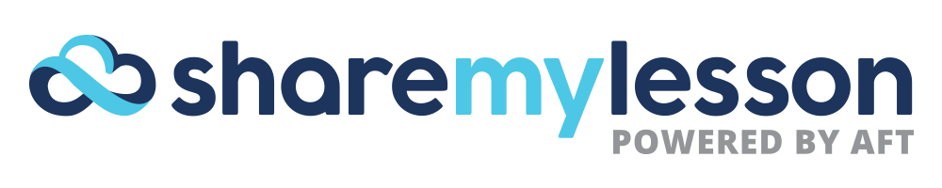

FACT SHEET

Share My Lesson is the nation’s fastest-growing free online professional development community where educators share their favorite and most successful lesson plans and other teaching resources while also collaborating on best practices. Share My Lesson has more than 308,000 resources, including a significant bank of lessons aligned to individual State Standards and guidance to aid in their successful implementation. The site currently has more than 928,000 subscribers, who review, upload and download resources at no charge.

At a Glance
- Members: 930,000
- Total resources: 310,000
- Resource downloads: 10,000,000+
- On-demand webinars: 100+

Website Overview
- Launched in July 2012, Share My Lesson is owned and operated by the American Federation of Teachers, a union of 1.6 million professionals.
- The first and largest online teacher resource bank ever developed and sponsored by a teachers union as a member offering.
- Created by and for educators, the site is also available to parents, paraprofessionals, school-related personnel and all others who work with students.
- Gives free access to high-quality, user-generated lesson plans, classroom activities, videos, handouts and quizzes, as well as editorial posts which support teachers, parents and the greater education community.
- Categorizes resources by grade level, subject matter, and theme.
- Includes a Common Core resource center of lessons and tips that have been aligned and vetted.

