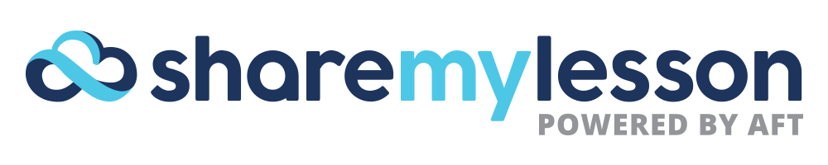

TALKING POINTS

AUDIENCE
Teachers:
- Teachers work on average of 50 hours per week. We know your time is both precious and limited. That’s why Share My Lesson is designed to provide the high-quality resources you need – quickly.

- In a 2014 Gallup Poll, teachers ranked last among 12 professional groups in agreeing that their opinion at work matters. Share My Lesson provides a platform to elevate teacher voice. Share your best lessons to be rated and reviewed by your peers or submit a blog post and become a thought leader on your subject or area of expertise.

- A strong partnership between schools and parents is pivotal to the academic success of students. Share My Lesson has materials that will help you build effective relationships with parents. Provide them with resources so they better understand their child's school environment and can complement the learning process at home.

- In addition to the thousands of materials shared by users on the site daily, Share My Lesson also has more than 300 content partners. Content partners – from Science Friday and NBC Learn to PBS NewsHour Extra and 60-Second Civics –provide free educational content and resources to teachers and parents directly on the site.

- Important news and current events can happen quickly and without notice, leaving you little time to prepare a lesson. Share My Lesson quickly meets this need by providing articles and aligned questions to guide classroom conversations in what’s called Today’s News, Tomorrow’s Lesson.

New-teachers:
- Within the first five years, thousands of young and once enthusiastic educators leave the teaching profession. Share My Lesson has the survival guide to help new teachers successfully navigate their way through the first few years. Get tips straight from source – veterans in the field – through our new teacher-specific resource center.

Paraprofessionals:
- As school-support staff, you play a critical part in developing a nurturing school climate. It’s been proven that your role can foster positive, trusting relationships with students by encouraging parent and family involvement in education. Share My Lesson provides specialized instructional resources, such as behavior management tips, bullying prevention, and working with special needs students, which support the important work you do.

OFFERINGS
Professional development:
- Consistent training is necessary to stay up-to-date on new research, emerging tools and trends and new curriculum. On Share My Lesson, you’ll find more than 90 hours of FREE professional development credit in the form of webinars that you can watch when and wherever you want.

State Standards:
- Adhering to state and national standards requires big transitions and changes to the professional lives of educators. Share My Lesson is committed to bringing you classroom resources aligned to standards to ease the potential difficulty of these transitions.

