MyPayMySay.com / The Mackinac Center for Public Policy
The Mackinac Center for Public Policy is a Michigan-based conservative thinktank and State Policy Network affiliate. The Mackinac Center has close ties to the DeVos family, which has donated at least $325,000 to the group since 1999. Dick DeVos, husband of Trump Education Secretary Betsy DeVos, served as the chair of the Center in the early 1990s. Mackinac also has close ties to the Great Lakes Education Project, an anti-teacher group founded by Betsy DeVos. In addition to the DeVoses, the Mackinac Center has received at least $3.3mn from the Koch-linked Donors Capital Fund.
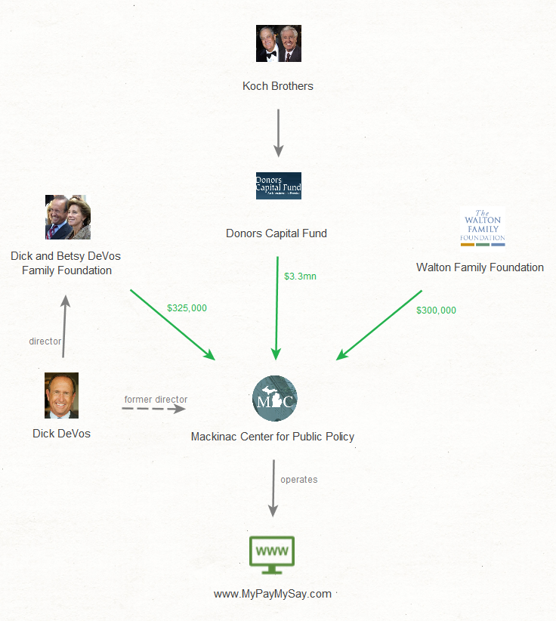

LeaveMyUnion.com / Illinois Policy Institute
The Illinois Policy Institute’s name isn’t anywhere to be found on the LeaveMyUnion.com website, which gives the impression that the site is not linked to this controversial group. Illinois Policy Institute (IPI) is a State Policy Network affiliate that has received $2.5mn in funding from Donors Trust and the Donors Capital Fund, two Koch-linked organizations that have been called the “dark money ATMs” of the conservative movement. IPI has also taken $600,000 from the Mercer Family Foundation, the private foundation of billionaire hedge fund manager Robert Mercer, whose family was the single largest donor to pro-Trump super PACs in the 2016 cycle. And, despite reports of a recent falling out, Illinois Policy Institute has both championed the work of Gov. Bruce Rauner and accepted $625,000 in donations from his family foundation.
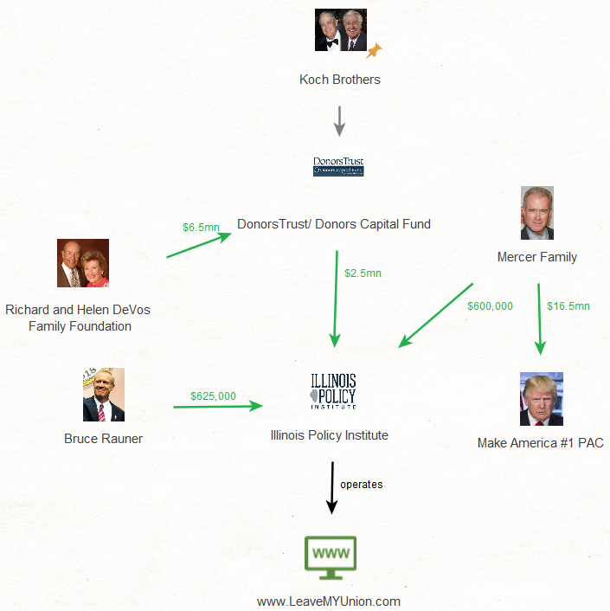

Freedom Foundation

The Evergreen Freedom Foundation is a State Policy Network affiliate located in Washington State. Since Harris v. Quinn, Freedom Foundation has waged an aggressive campaign to convince union members to leave their unions, using lawsuits, worksite canvassing, house visits, and automated dialers and direct mail. The Freedom Foundation receives funding almost exclusively from far-right organizations like the Koch-linked State Policy Network and Donors Trust.
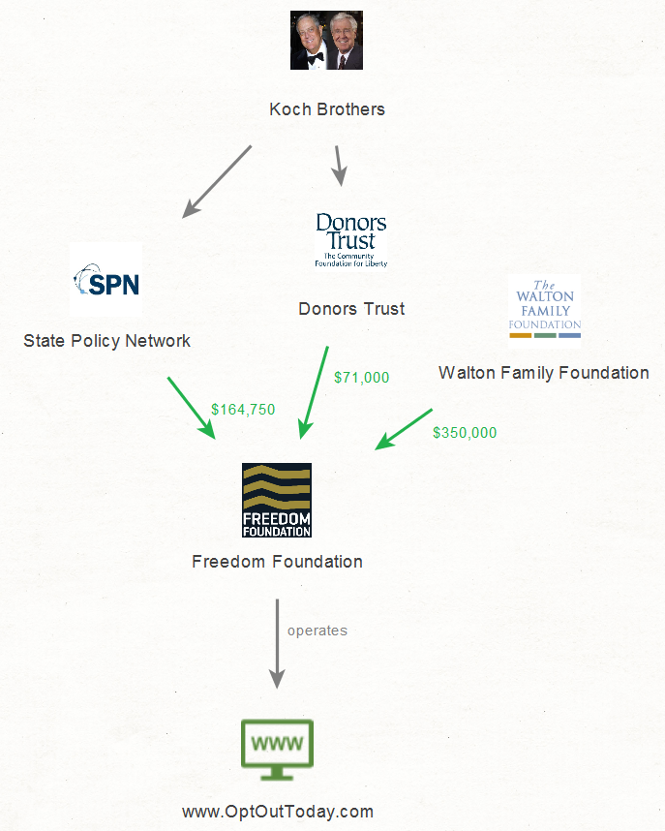

Dick and Betsy DeVos Family Foundation 990s 1999-2013
https://www.desmogblog.com/mackinac-center-public-policy
https://www.motherjones.com/politics/2014/01/devos-michigan-labor-politics-gop/
Donors Capital Fund 990s
https://www.illinoispolicy.org/opting-out-of-your-union-a-how-to-guide-for-illinois-teachers-public-safety-workers-and-other-public-employees/
Donors Trust and Donors Capital Fund 990s
Mercer Family Foundation 990s; https://www.washingtonpost.com/news/politics/wp/2018/04/05/the-amount-robert-mercer-spent-on-politics-in-2016-likely-topped-30-million/?noredirect=on&utm_term=.c261f2c55e02
http://www.sj-r.com/news/20180208/gov-rauner-clashes-with-illinois-policy-institutes-tillman
Donors Trust and Donors Capital Fund 990s

